10 Post Virtual Pop-Up Script
(With Scripts for Before and After Event)

Before POP-UP:

Post When Opening & Naming Thread:
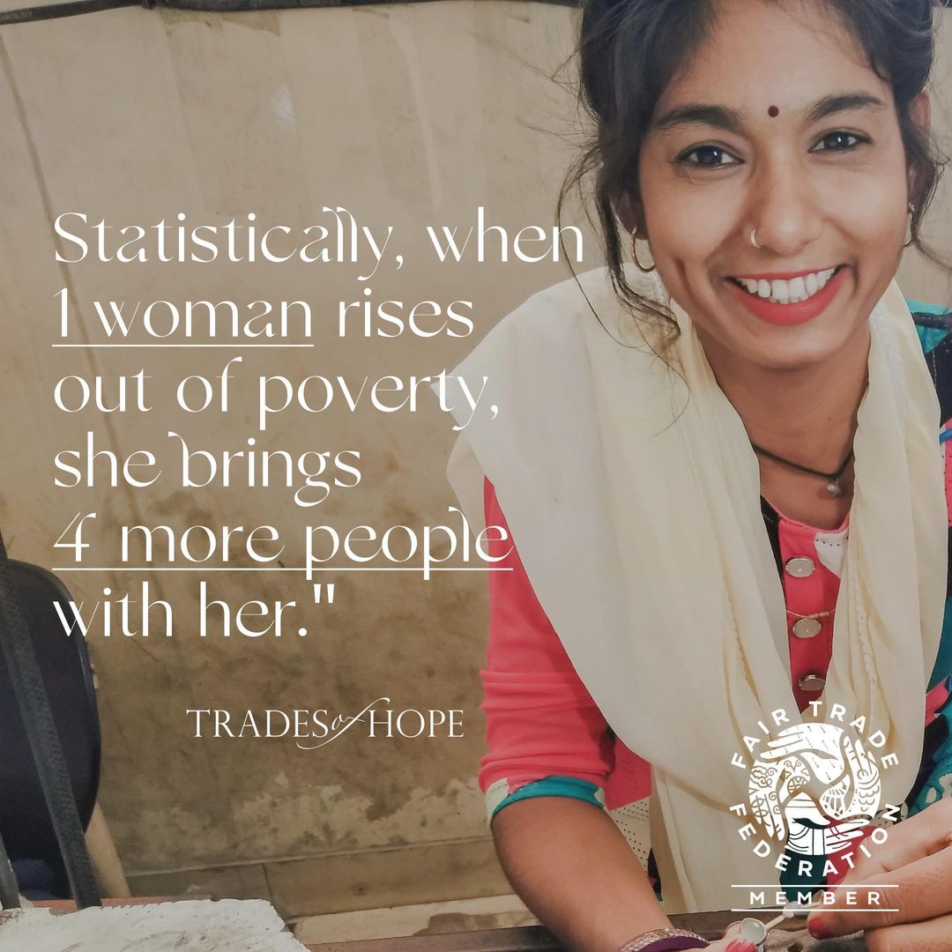
Hey, everyone! 🤍 Welcome to Megan’s virtual Trades of Hope pop-up!
I’m Elisabeth, a Partner with Trades of Hope. We’re an ethical fashion brand that creates jobs for women facing poverty. And what this means for YOU is that you’re helping to create safe, dignified jobs for women through something as FUN as shopping. And the real value is the fulfillment you feel putting on your accessory knowing you’ve stood with a woman who’s leading her family out of poverty.
Did you know? Statistically, when a woman rises out of poverty, she brings 4 more people out with her. (How cool is that?!)
Does standing with women by SHOPPING pieces YOU LOVE sound like something you’d be interested in? If so, you’re in the right place!
I can't wait to “see” you here when the virtual pop-up, well, “pops up” 😂 on Thursday, the 15th. But if you see something you’d like to shop before then, you can do so in Megan’s event link anytime! ⤵️
https://tradesofhope.com/eventshare/P21652/?u=influencer

Pre-Post 2 Days Before:
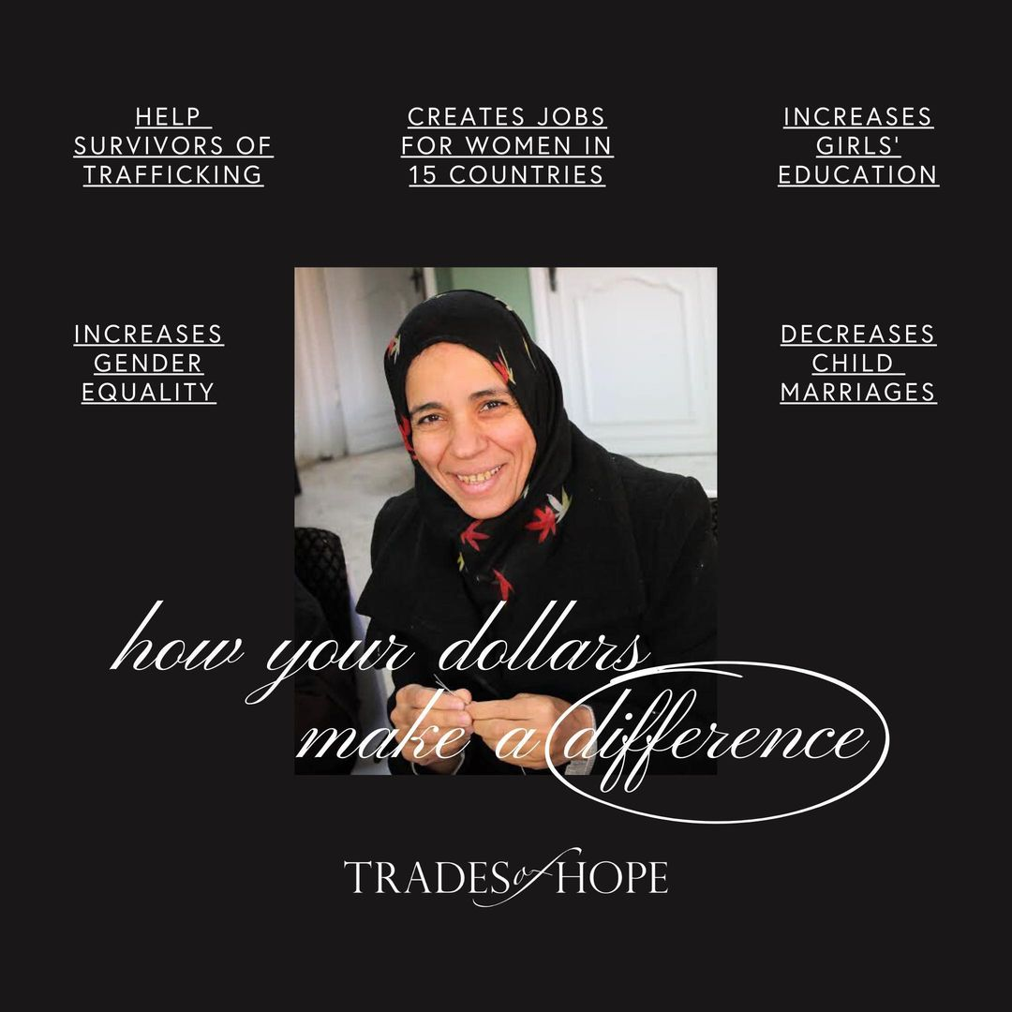
Just two days until Megan’s virtual pop-up, friends! You may be wondering, “How can superficial shopping make a global impact for women?” I get it! Let me explain:
The problem: Millions of women around the world lack job opportunities to break cycles of poverty. This forces mothers to give up kids to orphanages, propels human trafficking, and oppresses women.
The solution: We already know how to solve this. Creating safe, dignified, and fair jobs for women is proven to break cycles of poverty.
What this means for you: When you find ethically made accessories YOU LOVE, you’re helping to create more jobs for women. We couldn’t do this without YOU!
Here are just some of the ways your DOLLARS make a DIFFERENCE.
Just a reminder: here is Megan’s event link for you to browse! https://tradesofhope.com/eventshare/P21652/?u=influencer

Pre-Post 24 Hours Before:
See you tomorrow evening for Megan’s virtual Trades of Hope pop-up! 🤍 I’m going to drop 10 interactive posts for you Thursday at 8pm EST!
I wanted to let you know... You being here not only helps women globally, but also helps women in the U.S.! We partner with Elevate Academy (an online school for survivors) so that you can support survivors of human trafficking in the U.S. And the real value for you is the RELIEF of FINALLY being able to do something TABGLIBLE for a sometimes-overwhelming issue.
One survivor of human trafficking here in the U.S. said, “Elevate Academy has been literally the lifeline I needed to stay alive and get out.”
The more items shopped in this pop-up, the more days of Elevate Academy we sponsor for a survivor entering the program. I’d love for us to raise 5 days of Elevate Academy through this pop-up. Let’s do it! 🤍
Is supporting survivors in the U.S. something you’d like to have a hand in? If so, check out this video 🤍👉🏼 Elevate Academy Partnership (1.5 min)

Pre-Post Morning Of:
🤍 Who knows Megan best? 🤍 She told me which design she has her eye on… The first one to privately message me the answer wins a FREE SHIPPING coupon! Here are your options, DM me your best guess!
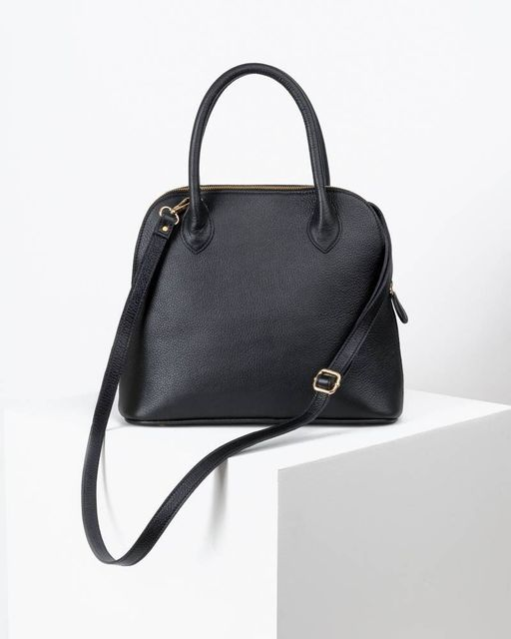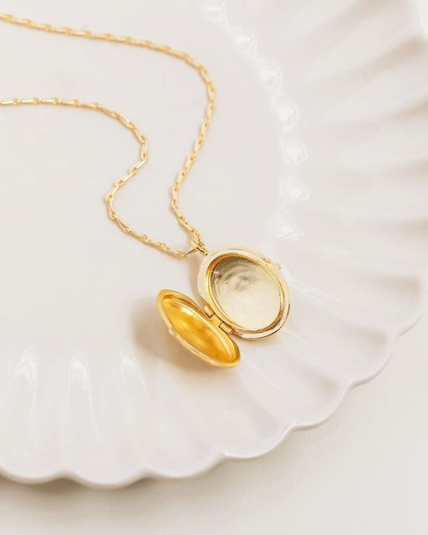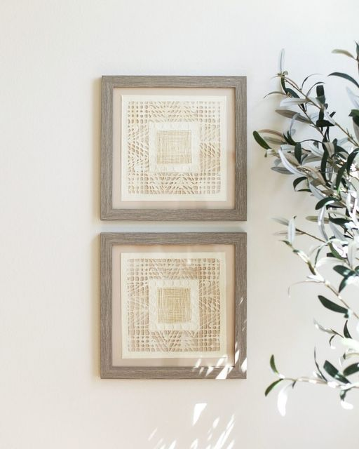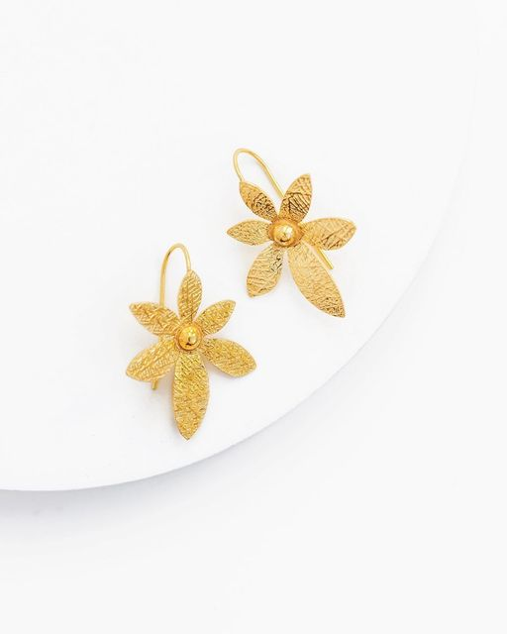

Pre-Post 1 Hour Before:
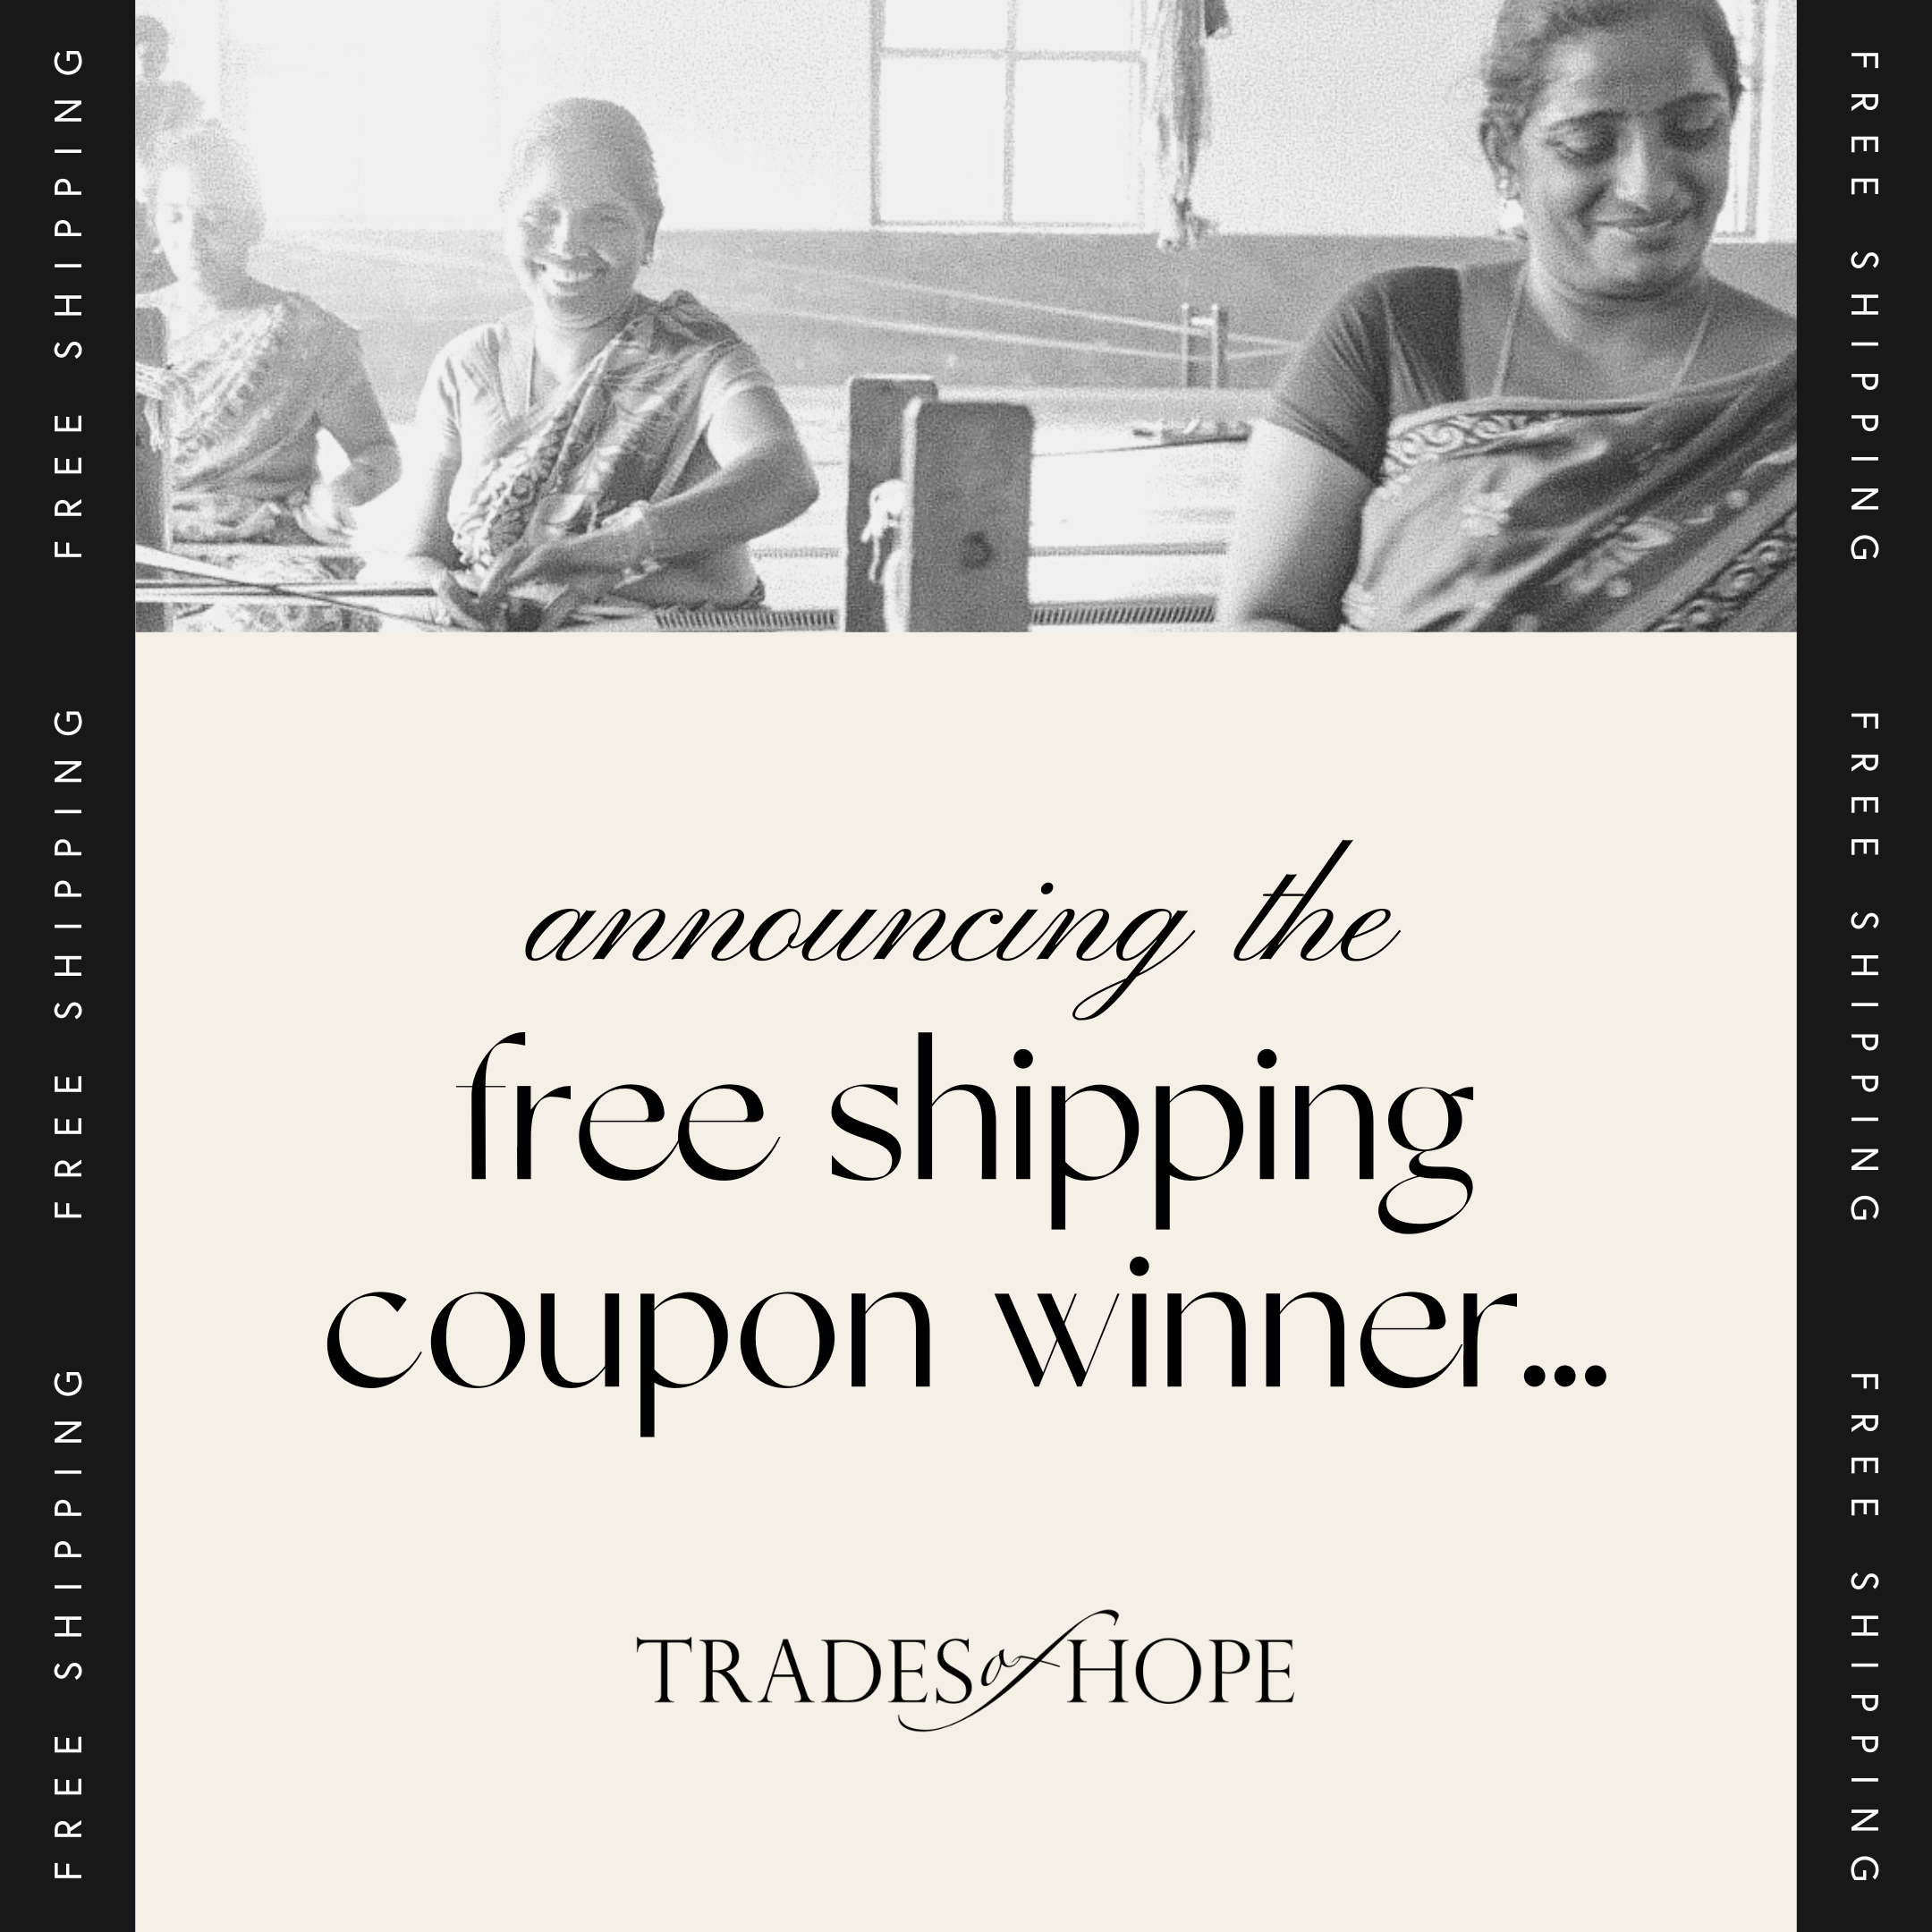
The COUPON WINNER IS.... @spencermd!!! Thank you to everyone who played along. (You are all such supportive friends!) See you back here tonight at 8pm EST for Megan’s pop-up!

Pre-Post 15 Minutes Before:
Friends! 🤍 Settle in with your fave music and beverage – it’s almost time for this pop-up to, well, POP UP! 🥰 Check out this video from one of our Artisan Partners, Florence in Uganda. She’s calling us to come together and stand with women around the world! (This gets me excited every time! 🤍)
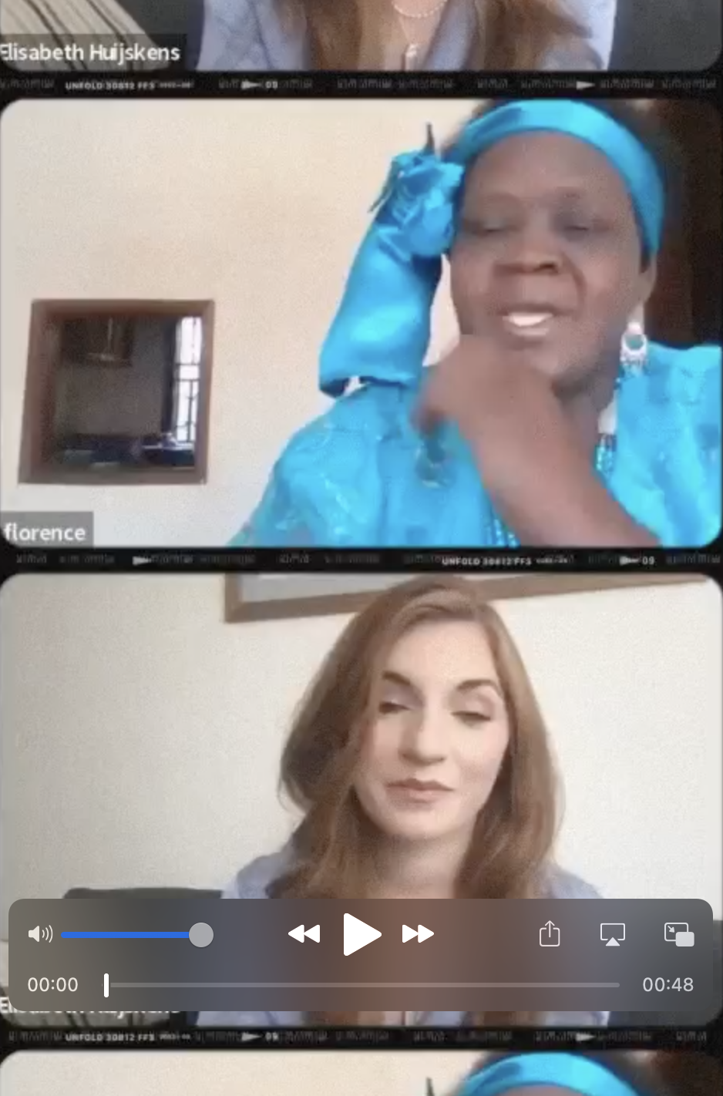

The POP-UP:

Pop-Up Post 1:
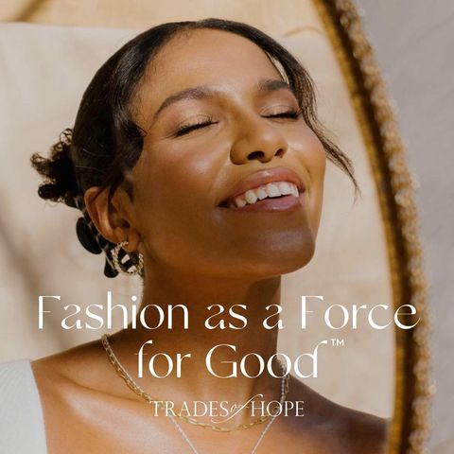
Hi friends! Welcome to Megan’s virtual Trades of Hope pop-up! I’m thrilled you’re here!
Trades of Hope uses fashion as a force for good.™ What that means for YOU is the ability to impact poverty and human trafficking by SHOPPING accessories you LOVE. And the real value is the fulfillment you’ll feel when you put your accessories on and know you’ve helped a woman who is leading her family out of poverty.
Asha, one of our Artisan Partners in India says, “We have a light joke in our workshop - that Trades of Hope has really given us hope!”
Does standing with women by shopping accessories you LOVE sound like something you’d enjoy? If so, ❤️ this message!

Pop-Up Post 2:
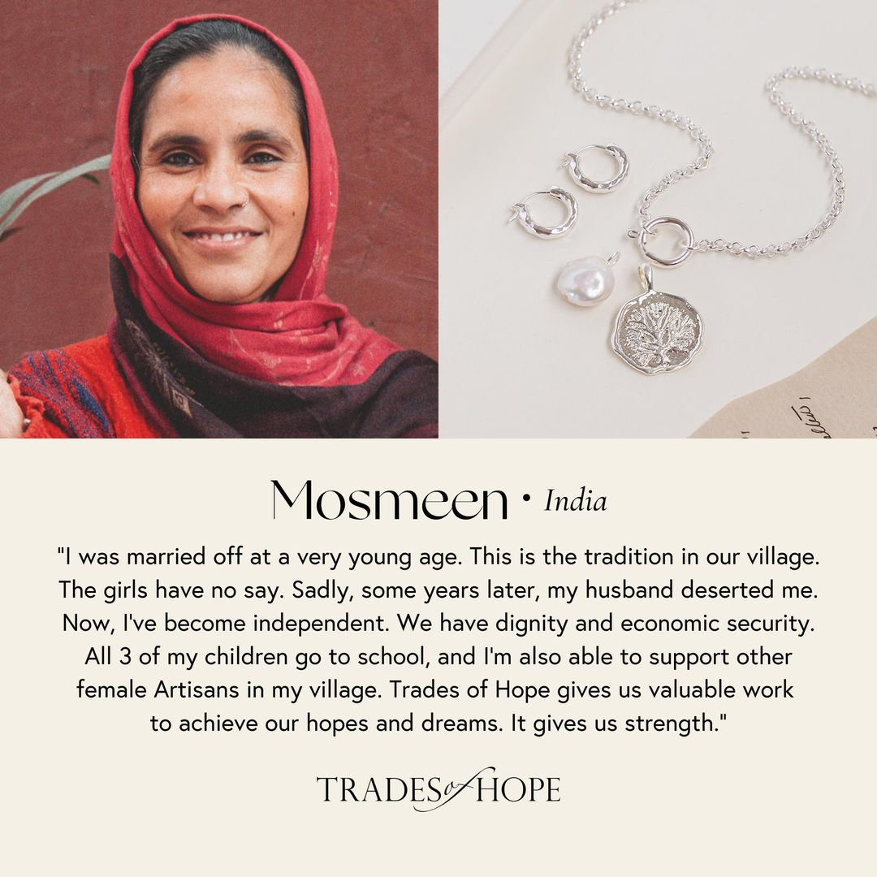
If there were a way YOU could create DIGNIFIED JOBS for women facing poverty in India by doing ONE THING you’re probably already doing, is that something you’d want to know more about?
Due to extreme poverty in India, women are often exploited in sweatshops + many parents marry off their child/teenage daughters. Thankfully, it doesn’t have to be this way. Have you done any shopping lately – either for yourself, your family or as gifts? If so, you’re already doing that ONE THING that can create more hope for women in Inda. Let me explain:
We offer accessories, bags, + decor ethically made by women in India so you can help them receive fair wages, health care, + literacy programs. The real value is the JUSTICE you’ll feel knowing you’ve helped a woman become the hero of her own story and RISE out of poverty.
❤️ this message if that resonates with you!

Pop-Up Post 3:
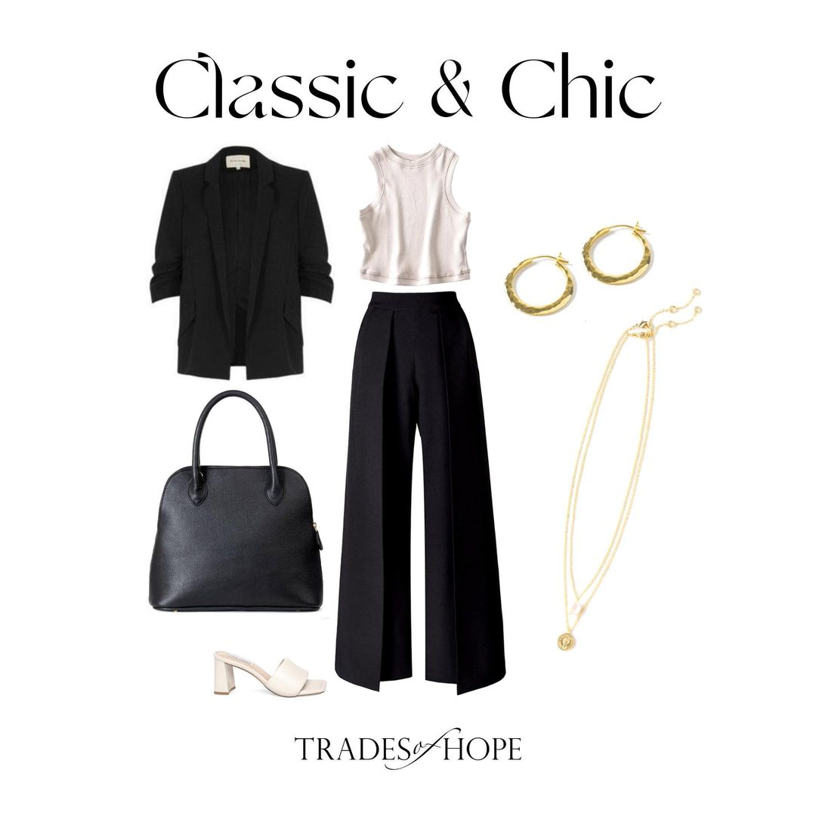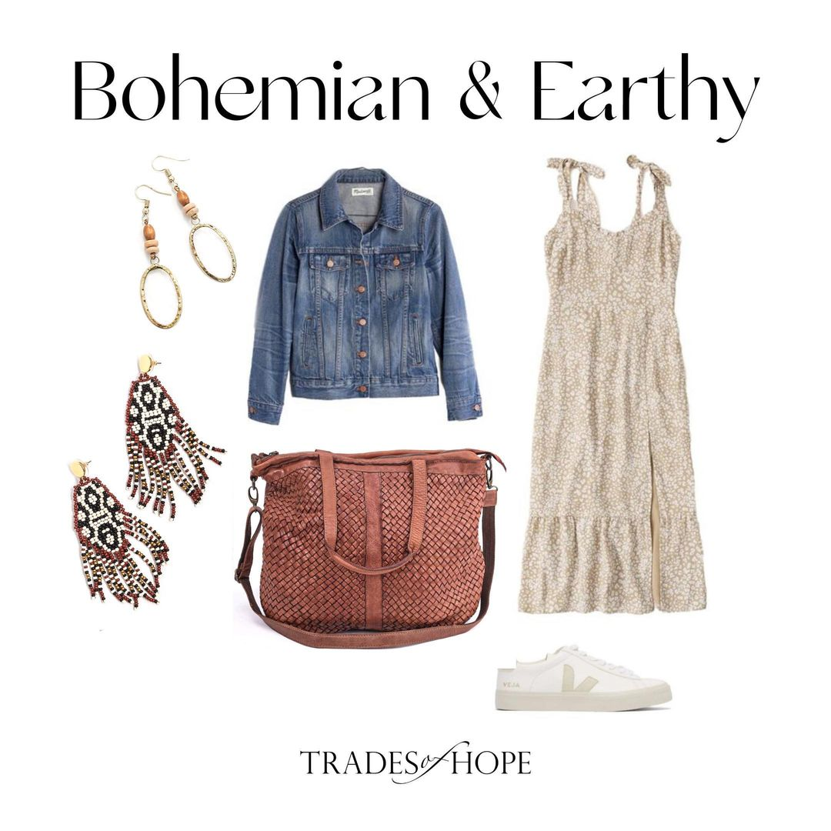
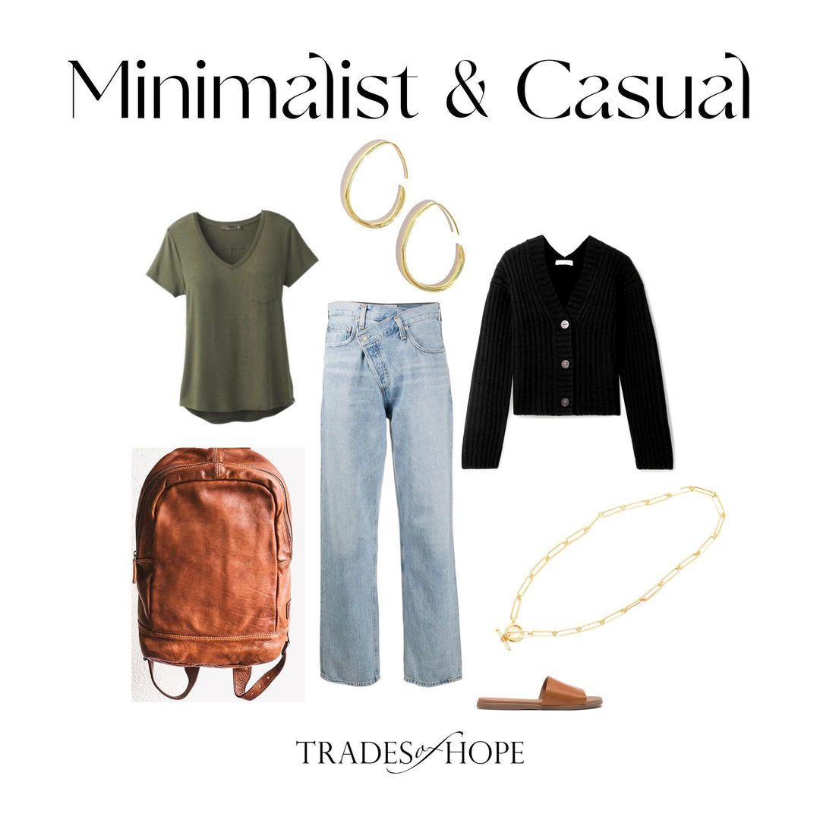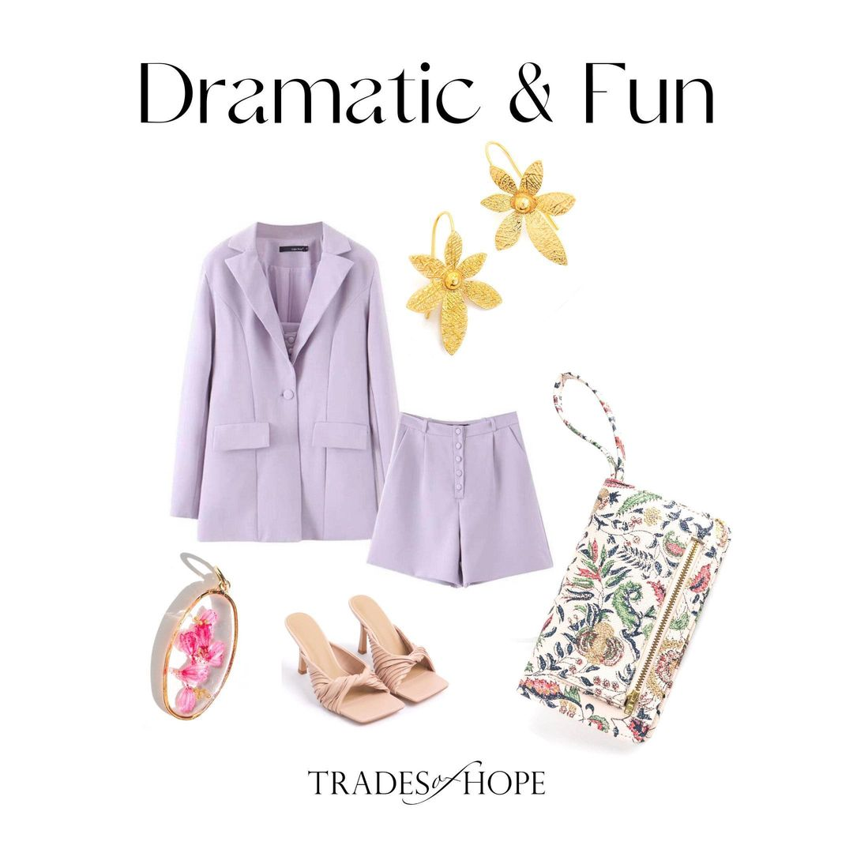
At Trades of Hope, we expand the idea of what fair trade products can LOOK like. We offer styles with a modern take on fair trade, inspired by today’s runways. We believe that everyone – including YOU – should be able to enjoy shopping pieces ethically made by women. That’s why we have designs for EVERYONE’S personal style and taste. Which style best describes YOU (or what you aspire to)?! Drop your answer in the thread! I’d love to know!
💄 – Classic and chic
🌞 – Bohemian and earthy
👟 – Minimalist and casual
💎 – Dramatic and fun

Pop-Up Post 4:
Some of our Artisans have told us: They don’t want purchases out of pity. Their eyes LIGHT UP when they find out women on the other side of the world LOVE to wear that they make! (Wouldn’t you feel the same?) They are overcoming poverty to become artists, designers, and businesswomen. So, let me be your personal stylist and help you find pieces YOU LOVE. You can shop collections according to your style by clicking Megan’s event link and opening the “New” menu! 🥳

Pop-Up Post 5:
How are our Artisan Partners paid? This is something I would want to know if I were in your position. Check out this linked video from Trades of Hope Founder and Chief Brand Officer, Elisabeth, to learn all the details on our dignified business partnerships. Give it a ❤️ after so I know you’re ready to move on! 👉🏼 “How much are Artisans paid?”

Pop-Up Post 6:
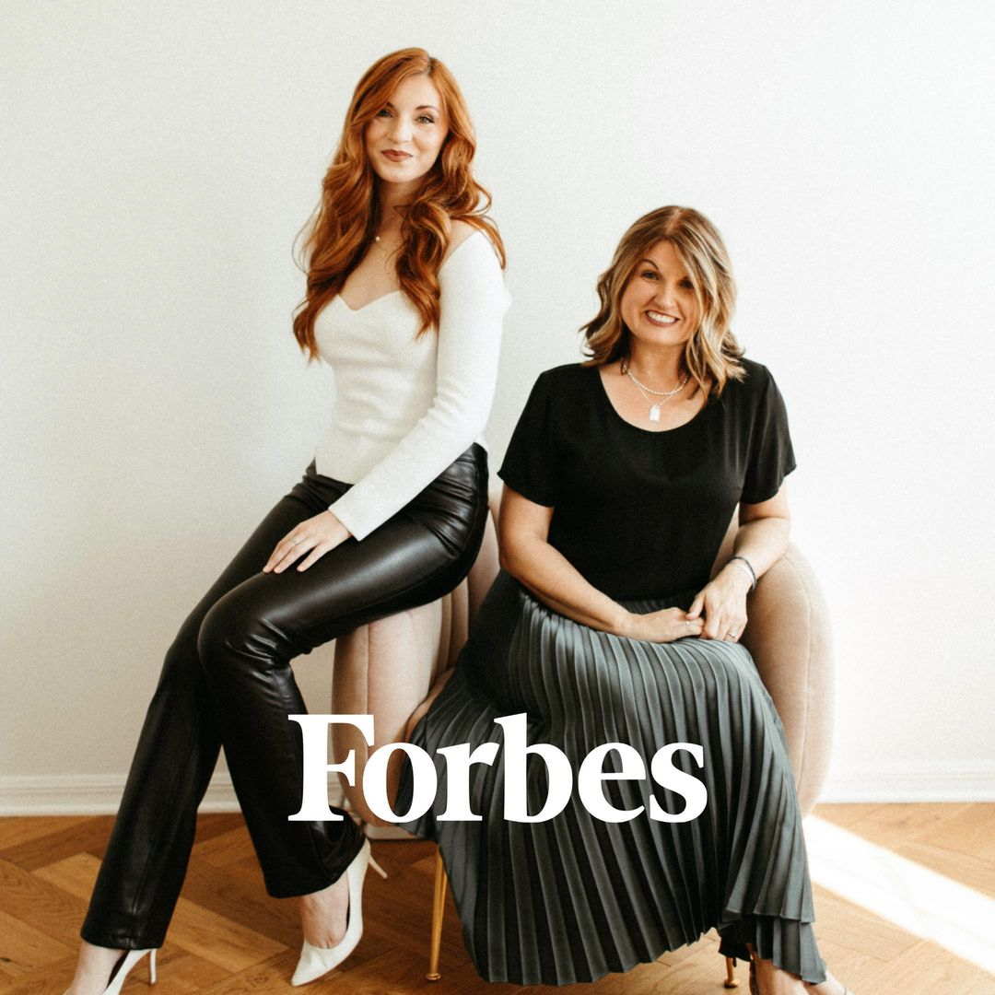
Can I tell you a quick story about how Trades of Hope started?
Founders Gretchen and Elisabeth (a mother-daughter duo) were forever changed by what they saw in Haiti. Gretchen founded an orphanage there and led it for almost a decade. Elisabeth grew up going to Haiti and was forever impacted by the experience. They both saw and experienced ways in which charity work can be awkward and undignified for the recipient. The most moving realization was that most of the children being given up for adoption had living, loving relatives! They just couldn’t afford to provide for their kids. Haiti is home to more than 500k children living in orphanages.
Deep down, they knew there had to be a better way to help these families.
There had to be a way to keep them together.
Out of this desire for justice, Trades of Hope was born. What if instead of adopting out their children, we could create jobs for mothers to be able to raise their children themselves? Today, with your help, Trades of Hope is doing this for women in Haiti and around the world. Women like Erna:

Pop-Up Post 7:
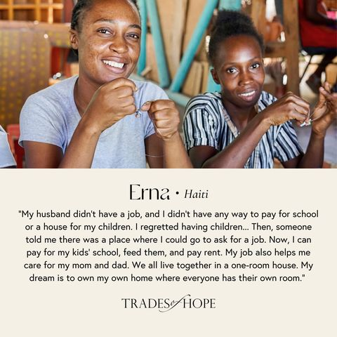
Every workday, mothers like Erna (left) overcome extreme poverty, political unrest, and gang violence to travel to their local workshop because there is no other opportunity to earn dignified income and to keep/provide for their children.
Erna is proof that, with a fair job, women can transform their lives. If you want to stand with women like Erna in Haiti, head to Megan’s event link and hit “Shop by Cause” to check out our products organized by country! 🌎

Pop-Up Post 8:
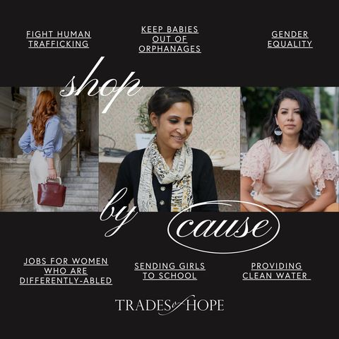
When you shop, you want it to align with the causes you care about, right? When women have jobs, EVERYONE’S lives are better. By standing with them, you’re impacting causes like these to improve whole communities.
Check out the collections curated by the causes important to YOU by clicking Megan’s event link and heading to “Shop by Cause.” Which cause is closest to YOUR heart? 🤍
👩‍🍼 – Help Mothers Keep Their Babies out of Orphanages
❤️ – Fight Human Trafficking
💪 – Gender Equality
📿 – Jobs for Women Who are Differently-Abled
👩‍🎓 – Sending Girls to School
💧 – Providing Clean Water
I’d love to see your answer in the thread and what’s important to YOU! 🤍

Pop-Up Post 9:
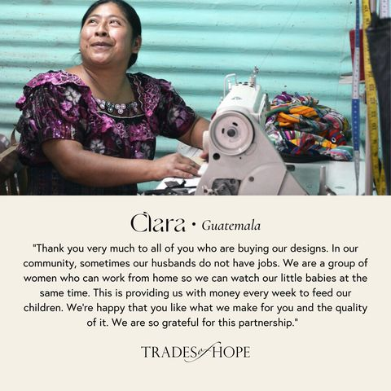
While it’s a beautiful country vast with culture, art, and talent, many parts of Guatemala are very male-dominated. This contributes to keeping women in cycles of poverty, abuse, oppression, + lack of education. But, because of their financial independence, the women we partner with are gaining respect, providing for their families, + becoming businesswomen.
Women like Clara!
Our Guatemalan designs include upcycled Huipil (traditional blouses worn by women), jewelry with fingerprints of the woman who made it for you, + stunning kimonos! But there’s one more surprise from this beautiful country…

Pop-Up Post 10:
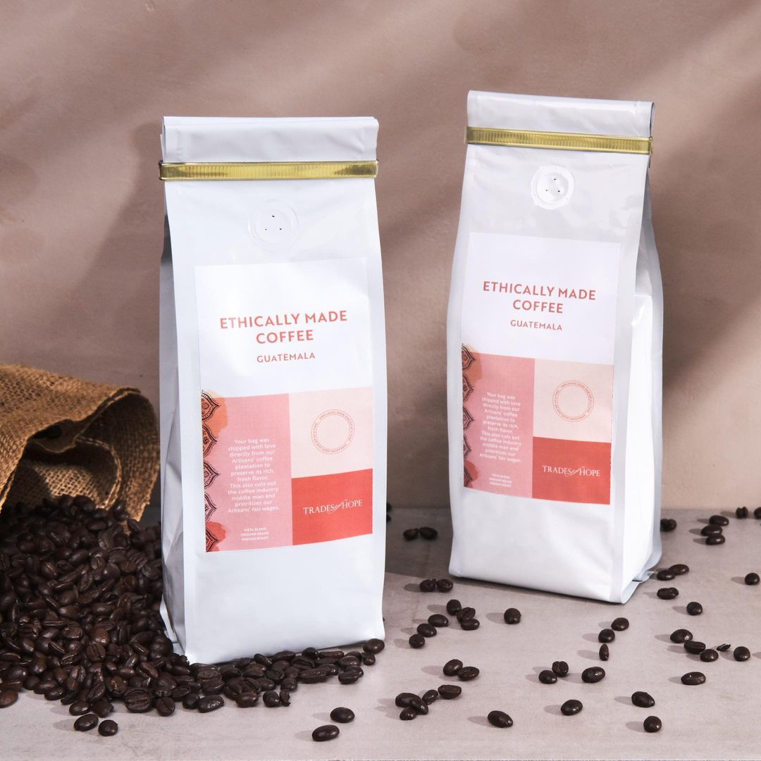
Not a jewelry person?
Our line includes bags, home décor, kids items, gift boxes... and even COFFEE! ☕️ If you’re a coffee drinker ❤️ this message!
Coffee makes up 70% of the Guatemalan economy so we believe we can transform the entire country via the coffee industry!
Sounds too good to be true? I could see that! But let me explain:
Our coffee is ethically sourced from microclimates with natural pest management, and hand harvested. Each bag provides fair wages, education, gender equality, AND gives back to babies in the NICU! 👶
⭐️⭐️⭐️⭐️⭐️ All the 5-star reviews on our website say that it’s the best coffee even self-proclaimed “coffee snobs” have tried! ☕️
If you want to try some coffee that TASTES good and DOES good, check out our options under the “Home > Coffee” tab on Megan’s event link! ☕️

Pop-Up Post 11:
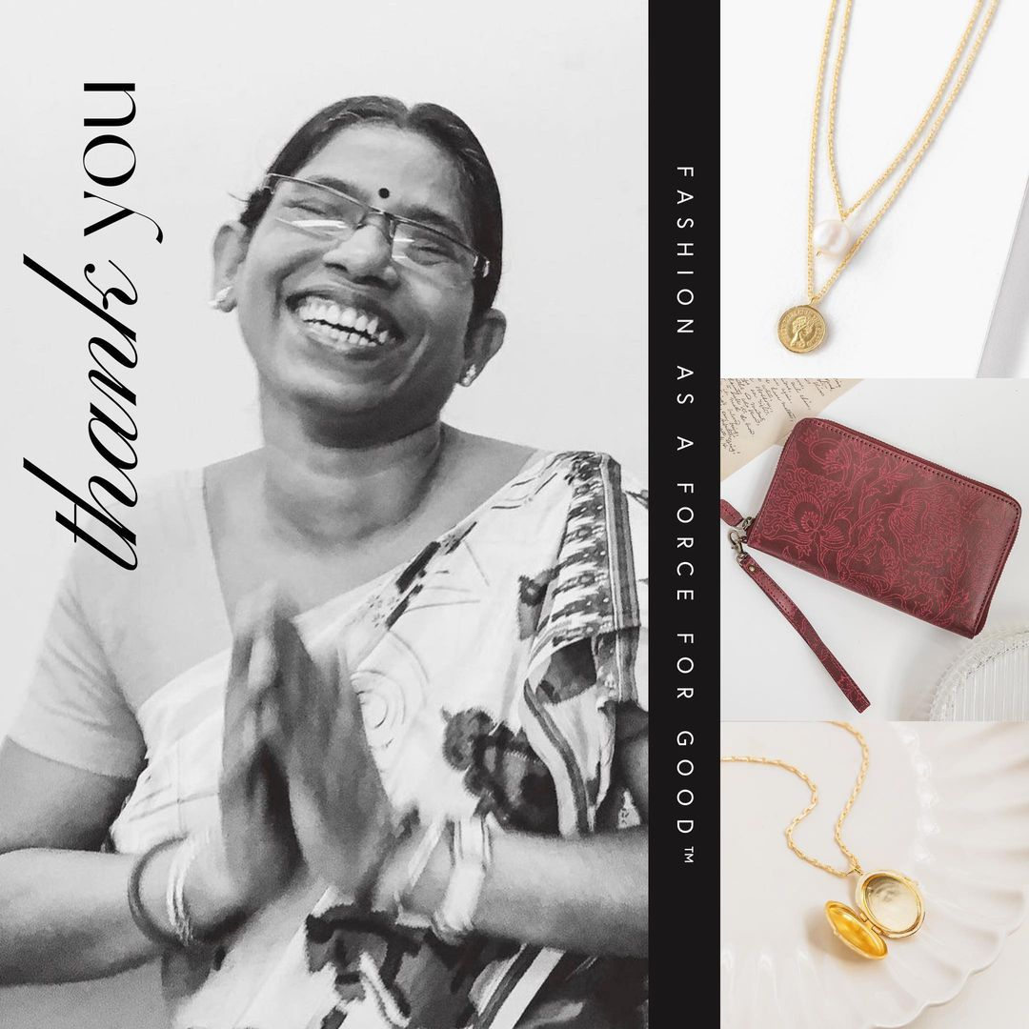
It’s the time you’ve all be waiting for... TIME FIND YOUR FAVES and HELP WOMEN around the world! 🌎🤍
Find your favorite styles here in Megan’s event link! (She gets some “thank you” gifts for bringing you together, so I know you want to ensure she gets credit for it!)
I’m going to close out Megan’s pop-up in a few days on Monday. But! I’ll be around if you want to message me privately with any questions about Trades of Hope or a design you see online. (I’m happy to send you an “in real life” photo/video of anything you are eyeing!) I can’t wait to see what you choose and how many days of Elevate Academy we give together!
THANK YOU, everyone, for attending Megan’s virtual pop-up! Without you, Trades of Hope would just be another ecommerce store on a mission. YOU make it a MOVEMENT. 🤍
https://tradesofhope.com/eventshare/P21652/?u=influencer

After POP-UP:

Post for Celebrating a Customer Order Example:
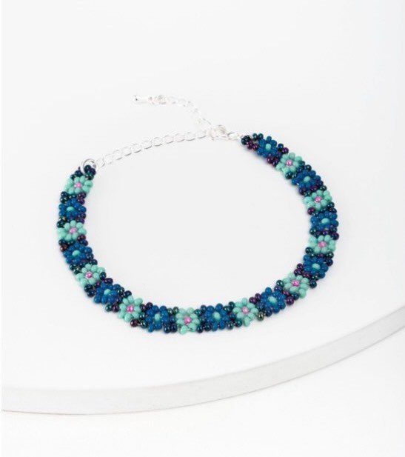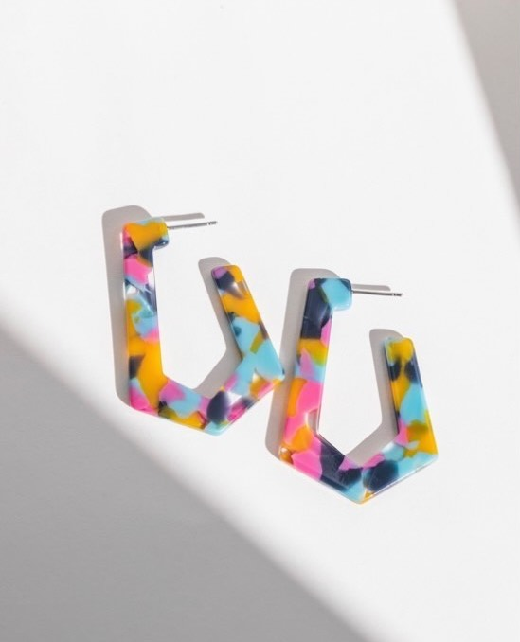
Want to take a moment to shout out SPENCER! By simple shopping styles she loves, she has helped women in Guatemala experience gender equality AND supported women rescued from trafficking in East Asia. (Plus she got 2 cute new accessories!) Thank you, Spencer!
As a reminder, you can shop Megan’s event link through Monday to stand with women globally AND help trafficking survivors here in the U.S. 🤍
👉🏼 https://tradesofhope.com/eventshare/P21652/?u=influencer

Post for Hosting:
Hey friends! Thank you again for being a part of this pop-up. Did you see a design (or two) that you liked? There may be a way you could receive your Trades of Hope faves for free, create MORE opportunities for the women we partner with, AND help survivors of trafficking in the U.S. Does that sound like something you’d be interested in? Like this message or shoot me a DM to learn how! 🤍

Post for Partnering:
Earn some extra cash AND make a difference in the world! 🌏
Trades of Hope Partners earn an income by sharing Trades of Hope accessories (as easily as you saw me do in this pop-up!). And what that means for you is earning an extra income on a flexible schedule AND helping women out of poverty and trafficking. And the real value for you is the PEACE OF MIND that comes from having some extra cash for you and your family.
Just last week, a Partner told me she left her job because of the income she's been earning! And she has never felt more fulfilled knowing her work is helping women in need AND allowing her to spend more time with her kids.
If earning some extra cash AND making a difference is something you’re interested in ❤️ this message or shoot me a DM for more info!

Last Day of the Pop Up:
Hi everyone! Today is your last day to shop your favorite accessories, décor, or gifts in Megan’s Pop-up! So far, this pop-up has sponsored 3 days of Elevate Academy for a survivor of human trafficking in the U.S. and help create life-changing, dignified work for women leading their families out of poverty!
Can we get to SPONSORING 5 DAYS for a human trafficking survivor? Shop your faves in Megan’s event link TODAY to reach our goal AND alleviate poverty for women globally! (Also, the more you shop, the more store credit Megan gets as a thank you for getting us together! 🤍)
👉🏼 https://tradesofhope.com/eventshare/P21652/?u=influencer

Final Post After Pop-Up Closes- Impact of the Pop-Up:
THANK YOU for being a part of Megan’s virtual Trades of Hope Pop-Up! Together, we have helped alleviate poverty and trafficking for women in Guatemala, East Asia, and India! AND we have SPONSORED 5 DAYS of Elevate Academy for a survivor of human trafficking in the U.S.! You have used fashion as a force for good!™ YOU have made the world a better place! Thank you!

